**DAILY ONLINE ACTIVITIES SUMMARY**

|  |  |  |  |  |  |  |  |  |
| --- | --- | --- | --- | --- | --- | --- | --- | --- |
| **Date:** | **31-05-2020** | | | | | **Name:** | **Apeksha Rane** | |
| **Sem & Sec** | **A** | | | | | **USN:** | **4AL17CS010** | |
| **Online Test Summary** | | | | | | | | |
| **Subject** | | **No exam** | | | | | | |
| **Max. Marks** | | **No exam** | | **Score** | | | **No exam** | |
| **Certification Course Summary** | | | | | | | | |
| **Course** | **INTRODUCTION TO CLOUD** | | | | | | | |
| **Certificate Provider** | | | COGNITIVE  CLASS IBM. | | **Duration** | | | 7hours |
| **Coding Challenges** | | | | | | | | |
| **Problem Statement:** No problem statement was given. | | | | | | | | |
| **Status: Done** | | | | | | | | |
| **Uploaded the report in Github** | | | | | **YES** | | | |
| **If yes Repository name** | | | | | <https://github.com/Apeksha12appu/19-5-2020-online-coding-activity> | | | |
| **Uploaded the report in slack** | | | | | **YES** | | | |

Online Test Details:

Subject: No exam.

Certification Course Details:

**Introduction to Cloud:**

Today I have studied  **Components of Cloud Computng.**

* Introduction and Objectives.
* Overview of Cloud Infrastructure
* Virtualization and Machines Explained
* Types of Virtual Machines
* Bare Metal Servers
* Secure Networking in Cloud
* Containers

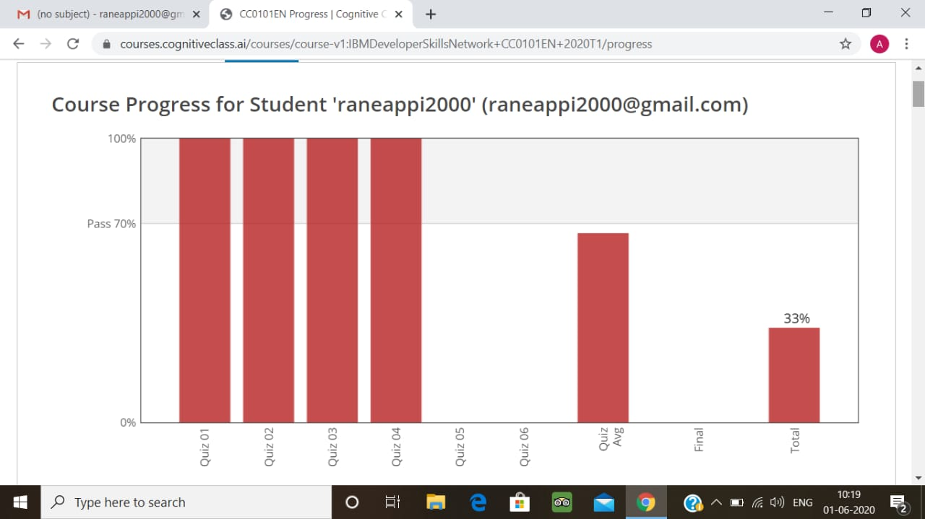

Coding Challenges Details:

No coding Challege.